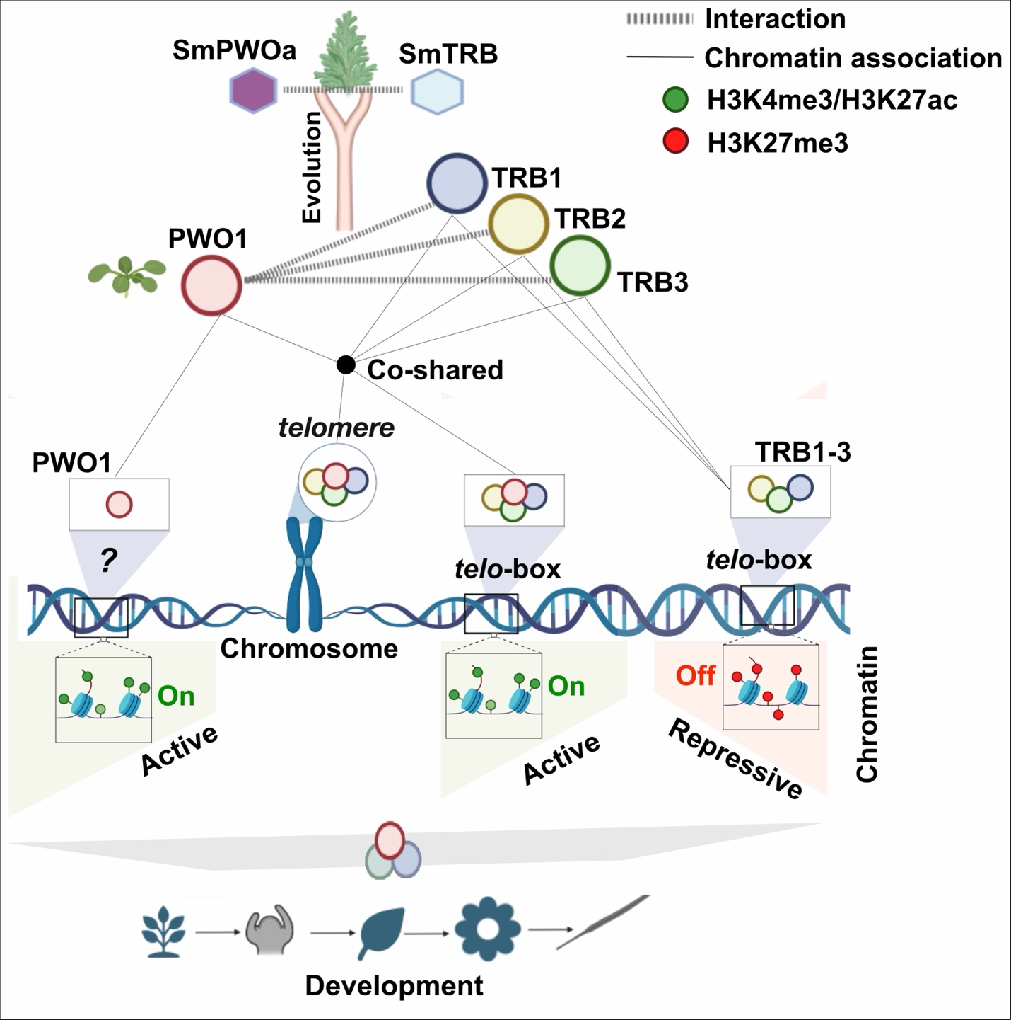

Evolutionarily conserved PWO–TRB interactions and their shared roles in Chromatin regulation and plant development. Created with BioRender.com.

